Western Blot Protocol
- Equipment: Holder, Electric holder, Top glass plate, Glass plate with spacer and Comb.
- Wash each equipment with distilled water
- Assemble the equipment.
- Check with the comb and mark a little below the bottom on the glass plate for the level between the resolving and stacking gels.
- Fill it with water (with pipette) to see if it’s not leaking from below.
Casting the gel
- Determine the molecular weight of the protein you want to measure to select the concentration of polyacrylamide gel. (bigger proteins, use 8% gel, for smaller proteins, use 12% gel).
- Take the list of ingredients needed for the gel.
- Mix all of them in a 50 ml falcon tube except the APS and Temed, and swirl.
- Pour out water from the equipment completely.
- Add APS and Temed to the mixture.
- Pipette the mixture between the two glasses until the mark.
- Leave it standing for 20-30 minutes until gel polymerises.
- Prepare the stacking gel similarly, load it, place the comb taking care not to have any bubbles and leave it standing until the gel polymerises.
Loading the samples
- Take the samples and pipette up and down.
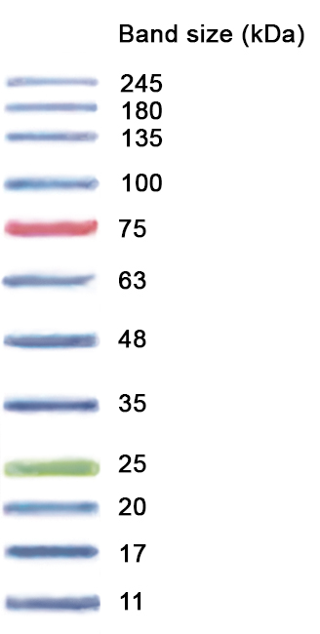
- Assemble the holder and electric instrument along with the gel. Fill the space behind the glass plate and the holder with running buffer until the wells are completely covered. Also add buffer to the running tank.
- Load 5 μL of ladder (NZY Colour Protein Marker II)
- Load each sample.
- Connect leads black to black and red to red.
- Run at 150V for 1h45min.

Taking out the gel
- Take a plate out with the help of the handle.
- Cut any excess gel especially stacking gel with it.
- Pour transfer buffer on the gel.
- Prepare a box with a little transfer buffer.
- Lift the gel slowly and place it in the box.
Transfer of membrane
- Two types of membrane i. PVDF (Polyvinylidene Fluoride) for smaller proteins (mostly used in the lab) and ii. Nitrocellulose
- Take a mould and cut the membrane around it. Wrap the roll of membrane in plastic and put it back.
- Activating the PVDF membrane: Put the membrane with fórceps in a very clean box and put methanol (100%) to cover it for a little bit.
- Pour the methanol back into container.
- Rinse the membrane with distilled water.
- Put Transfer buffer over the membrane to cover it.
Sandwich
- Take the Trans Blot SD Semi Dry Transfer Cell and 2 filter papers.
- Soak the filter papers in transfer buffer and place one of them on the holder.
- Place the membrane with fórceps on the filter paper.
- Put some buffer over the membrane to prevent it from drying.
- Place the gel over the membrane and put some buffer on top.
- Apply rolling pressure with a glass tube to remove bubbles.
- Place the second filter paper over the gel and apply pressure again.
- Dry the area around the filter paper.
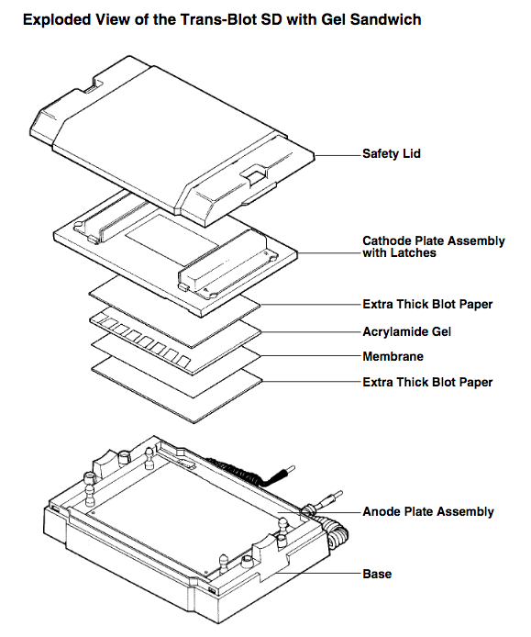
- Put the lid, lock it and connect it to Voltage 12V and transfer for 25-30min (for small proteins less than 30kDa) and 50min (for bigger ones), if the transfer buffer doesn’t have methanol. Reduce times by half if the transfer buffer contains methanol).

Staining the gel (optional)
- After transfer, pour Instant Blue superstain to cover the gel.
- Wait for 15-60 minutes to see distinct bands.
- Pour water to cover the gel O/N
Blocking for non-specific binding
- Pour some 5% milk in TBST (Tris-Buffered Saline and Tween-20) in a box.
- Take membrane out of the holder and cut the bottom right edge.
- Put the membrane in the box to cover it with milk and leave it to agitate for about 1 hour.
Primary Antibody
- Rinse the membrane with some TBST.
- Prepare primary Ab in 2% BSA in TBST and 0.02% Sodium Azide. (Dilutions: Anti P-ATM Antibody, Dilution is 1:1000; Anti Chk-2 Antibody, dilution is 1:1000)
- Add the primary Ab to the membrane in an falcon and leave to incubate at 4⁰C O/N. The stock falcon tube should be labeled with Dilution, Date and Source of antibody, so that the antibody can easily be reused.
Secondary Antibody
- Put primary antibody back to the stock falcon tube (can be reused).
- Rinse once with some TBST.
- Pour a little more TBST and place it on the roller for about 10 minutes.
- For Secondary Antibody, dilution is 1:5000. (Do not put Sodium Azide as it inhibits HRP). Mix in 5% milk in TBST. Check the origin e.g. Goat anti-rabbit HRP or anti-mouse or anti-rat HRP. If the primary antibody is rabbit, use secondary Goat anti-rabbit HRP antibody.
- Incubate in a roller for 1 hour at room temperature.
- Rinse once with some TBST.
- Pour a little more TBST and place it on the roller for about 10 minutes. Do this a total of 3 times.
Chemilumescent Substrate
- Take the substrate box from the fridge (labelled Supersignal WestPico Chemilumescent Substrate HRP)
- 2 components: Peroxide solution and Luminor Enhancer Solution.
- Take the paraffin membrane and fix it on the glass bench.
- Mix the two components 1:1 on the membrane with a pipette. The total volume should be 1ml drop per whole membrane.
- Take the membrane out with fórceps, holding it at the end to not disturb the proteins and wipe it on a bit of paper and place it on the drop with protein facing down.
- With a 50ml pipette tip, remove bubbles and leave to incubate from 2-5 minutes.
- Take a plastic sheet and put it in the casette and stick one end with tape.
- Place the membrane between the two plastic sheets with protein facing up, wipe with paper to remove excess substrate, place a paper over it and close the cassette.
Developing the Western Blot (optional)
- In the dark room, in red light (no other light can be on), take out the film and cut it to size.
- Place it in cassette and close it and leave it for exposure.
- Take 3 solutions: Developer, Water and Fixer in trays.
- After developer, wash in water, then fixer and rinse in tap water and dry.

TBST 1x (concentrated Tris-Buffered Saline with Tween-20), 20L
- 48 g Tris base (Formula weight: 121.1 g, final conc 20 mM)
- 176 g NaCl (Formula weight: 58.4 g, final conc 150 mM)
- Dissolve in distilled water (add about 5L)
- pH to 7.4-7.6 with HCl
- Add distilled water to a final volume of 20L
- Add 20 ml of Tween-20 (final conc 0.1%) and mix well
Running Buffer 10x, 1L
- 30.2 g Tris base
- 144.2 g Glycine
- 10 g SDS
- Dissolve in 1000 ml distilled water
Store at RT
Note: Is important to use SDS from powder; do not use from the 20% SDS
Transfer Buffer (Bjerrum and Schafer-Nielsen) 1x, 1L
- 5.82 g Tris
- 2.93 g glycine
- Add distilled water up to 1L (don’t use MiliQ water)
Keep it at 4⁰C
Note: for nitrocellulose membranes add 20% methanol (200ml in 1L of transfer buffer)

